Ans: -34.6



Ans: +72J



Ans: -26 J

Ans: 103o

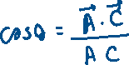

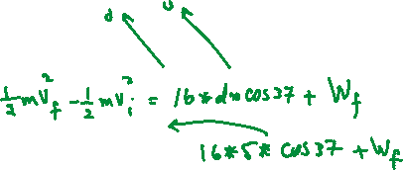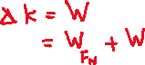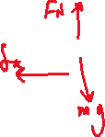

Ans: -33.9 J



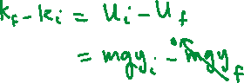

Ans: 11.76 J



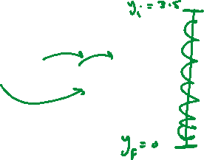

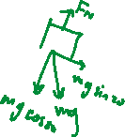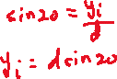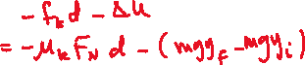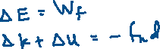



Ans: 1.98 m/s

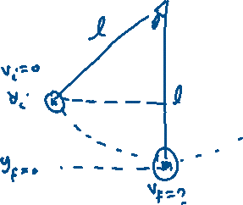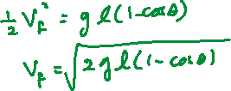



Ans: 3.67 m/s

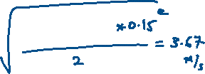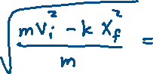

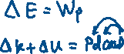

Ans: 0.85 m/s

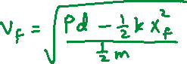

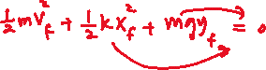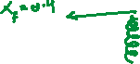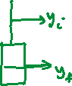

Ans: 2.2 m/s

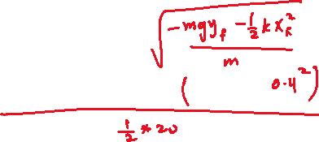



Ans:



What average power (magnitude) is generated by a 70.0-kg mountain climber who climbs a summit of height 325 m in 95.0 min? (Ans. 39.1 W)

